

Lab Journal: 06
Date: 10/14/2025

Student : Lotfullah Muslimwal
Enrollment : 01-131232-039

Department of Software Engineering

Bahria University, Islamabad

Software Construction-Lab (Fall-2025)
Teacher: ENGR. SAAD MAZHAR

Task No: | Task Wise Marks |  | Documentation Marks |  | Total Marks  (20)
Task No: | Assigned | Obtained | Assigned | Obtained | Total Marks  (20)
1 | 3 |  | 5
2 | 3 |  | 5
3 | 3 |  | 5
4 | 3 |  | 5
5 | 3 |  | 5

Comments:

Signature

Lab 05 – Using Maps for Associations and Using Library Classes

GitHub Repo: Lab 5 Code

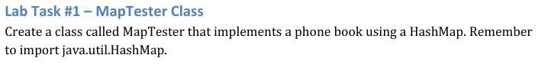

Code for Task 1
import java.util.HashMap;
import java.util.Scanner;
public class Task1 {
private HashMap<String, String> contacts = new HashMap<>();
public void addContact(String personName, String phoneNumber) {
if (contacts.containsKey(personName)) {
System.out.println("The name " + personName + " already exists. Do you want to update the number? (yes/no)");
Scanner input = new Scanner(System.in);
String choice = input.nextLine().trim().toLowerCase();
if (choice.equals("yes")) {
contacts.put(personName, phoneNumber);
System.out.println("Updated " + personName + "'s number to " + phoneNumber);
} else {
System.out.println("No changes made for " + personName);
}
return;
}
if (contacts.containsValue(phoneNumber)) {
System.out.println("This number is already saved under another name.");
for (String key : contacts.keySet()) {
if (contacts.get(key).equals(phoneNumber)) {
System.out.println("Existing entry: " + key + " -> " + phoneNumber);
}
}
System.out.println("Do you still want to save it? (yes/no)");
Scanner input = new Scanner(System.in);
String choice = input.nextLine().trim().toLowerCase();
if (!choice.equals("yes")) {
System.out.println("Contact not saved.");
return;
}
}
contacts.put(personName, phoneNumber);
System.out.println("Saved contact: " + personName + " -> " + phoneNumber);
}
public void findContact(String personName) {
String number = contacts.get(personName);
if (number != null) {
System.out.println(personName + "'s number is " + number);
} else {
System.out.println("No record found for " + personName);
}
}
public void showAllContacts() {
if (contacts.isEmpty()) {
System.out.println("No contacts available.");
return;
}
System.out.println("\nAll saved contacts:");
for (String name : contacts.keySet()) {
System.out.println(name + " -> " + contacts.get(name));
}
}
public void deleteContact(String personName) {
if (contacts.containsKey(personName)) {
contacts.remove(personName);
System.out.println(personName + " removed from the phonebook.");
} else {
System.out.println("No record found for " + personName);
}
}
public static void main(String[] args) {
Task1 phoneBook = new Task1();
Scanner in = new Scanner(System.in);
while (true) {
System.out.println("\n1. Add contact");
System.out.println("2. Find contact");
System.out.println("3. Show all contacts");
System.out.println("4. Delete contact");
System.out.println("5. Exit");
System.out.print("Select: ");
int choice = in.nextInt();
in.nextLine();
if (choice == 1) {
System.out.print("Enter name: ");
String name = in.nextLine();
System.out.print("Enter number: ");
String number = in.nextLine();
phoneBook.addContact(name, number);
} else if (choice == 2) {
System.out.print("Enter name: ");
String name = in.nextLine();
phoneBook.findContact(name);
} else if (choice == 3) {
phoneBook.showAllContacts();
} else if (choice == 4) {
System.out.print("Enter name to delete: ");
String name = in.nextLine();
phoneBook.deleteContact(name);
} else if (choice == 5) {
System.out.println("Closing phonebook.");
break;
} else {
System.out.println("Invalid choice.");
}
}
in.close();
}
}

Screenshot
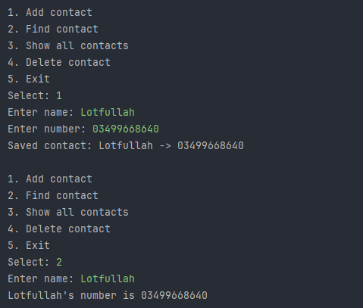
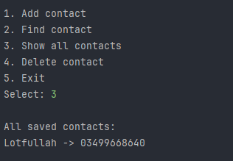

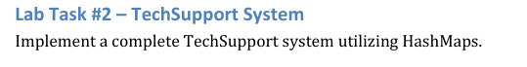
Code for Task 2
import java.util.*;
public class Task2 {
private HashMap<String, List<String>> helpData = new HashMap<>();
private List<String> chatHistory = new ArrayList<>();
private Scanner in = new Scanner(System.in);
private Random random = new Random();
public Task2() {
setupHelpData();
}
private void setupHelpData() {
helpData.put("slow", Arrays.asList(
"Try restarting your system and closing unused programs.",
"Clear temporary files. They sometimes slow down the computer.",
"Make sure your disk isn’t full. That affects performance."
));
helpData.put("internet", Arrays.asList(
"Check if your Wi-Fi is connected properly.",
"Try restarting the router.",
"Test another device to confirm if the issue is with your connection."
));
helpData.put("battery", Arrays.asList(
"Lower the screen brightness to save power.",
"Close background apps you aren’t using.",
"Consider replacing the battery if it drains too fast."
));
helpData.put("error", Arrays.asList(
"Can you share the error message you’re seeing?",
"Try restarting the app showing the error.",
"It might help to reinstall the program."
));
helpData.put("update", Arrays.asList(
"Check if system updates are pending.",
"Updates can fix bugs and performance issues.",
"Avoid turning off your system during updates."
));
}
private String findReply(String userLine) {
userLine = userLine.toLowerCase();
for (String word : helpData.keySet()) {
if (userLine.contains(word)) {
List<String> replies = helpData.get(word);
return replies.get(random.nextInt(replies.size()));
}
}
return "I’m not sure about that. Could you explain your problem a bit more?";
}
private void startChat() {
System.out.println("Tech Support Assistant");
System.out.println("Type 'bye' when you’re done.\n");
while (true) {
System.out.print("You: ");
String userLine = in.nextLine().trim();
chatHistory.add("You: " + userLine);
if (userLine.equalsIgnoreCase("bye")) {
System.out.println("Support: Glad I could help. Goodbye.");
break;
}
String reply = findReply(userLine);
System.out.println("Support: " + reply);
chatHistory.add("Support: " + reply);
}
showHistory();
}
private void showHistory() {
System.out.println("\nConversation Summary:");
for (String line : chatHistory) {
System.out.println(line);
}
}
public static void main(String[] args) {
Task2 bot = new Task2();
bot.startChat();
}
}

Screendshot
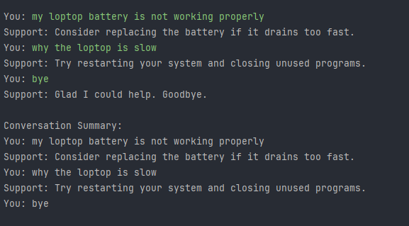

Conclusion

In this lab, I learned how to use Java’s built-in library classes and the HashMap collection to build real, practical applications. In the first task, I created a simple phonebook system that stores and manages contacts using a HashMap, allowing me to add, find, display, and delete contacts while also handling cases where two entries share the same name or phone number. This helped me understand how keys and values work in a map and how duplicate keys replace older values while duplicate values are allowed. In the second task, I implemented a Tech Support system that uses a HashMap to store keywords and multiple related responses. The program reads user input, detects keywords, gives suitable replies, handles unknown inputs with default messages, and even keeps a record of the full conversation. Together, these tasks showed how HashMaps make it easy to associate data, search efficiently, and build more flexible and interactive applications in Java.

